Production of Eastern Bluebirds in Monitored Houses

Annual Report - 2005

Brice Prairie Conservation Association

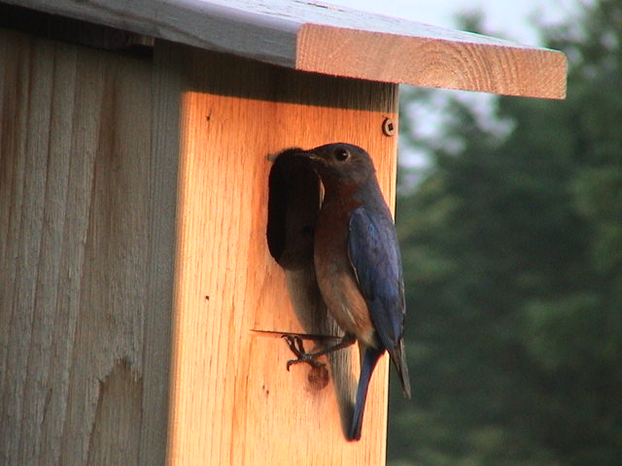

By

Leif L. Marking, Project Manager

W7917 CTH ZB
Onalaska, Wisconsin 54650
cmarking@centurytel.net
(608) 781-0323

Production of Eastern Bluebirds in Monitored Houses

Introduction: Bluebirds are cavity nesting song birds that are unable to create their own nesting cavities. Natural cavity availability declined significantly when non-native House Sparrows and European Starlings were introduced to this country over 150 years ago because they were victorious competitors for nest cavities and vicious predators of bluebird eggs and young. However, bluebird populations have been increasing since the birth of the North American Bluebird Society (NABS) in 1978 followed by many state chapters such as the Bluebird Restoration Association of Wisconsin (BRAW). Our Brice Prairie Conservation Association (BPCA) members have recorded our bluebird production activities since 1992 and reported the numbers to the above organizations annually. Technical information and instructions for producing bluebirds are available from websites of NABS (www.nabluebirdsociery.org), BRAW (www.BRAW.org), and BPCA
(www.briceprairieconservation.org). The purpose of this report is to summarize the numbers of bluebirds produced by club members this year, recognize increases over last year, identify problems that influenced production, and evaluate procedures to increase future production.

Procedures: We have selected the NABS-style house to promote bluebird production because the design is so practical, it is easy to construct, maintain, and clean, and bluebirds readily occupy it. These cedar houses are mounted on 7-foot steel T-type fence posts that are covered with a 5 ft. section of PVC pipe (1 ½”) for mammalian predator control. The houses are placed 200 yards or more apart to respect the territorial nature of bluebirds and to encourage maximum production of bluebirds. New houses are built without air vents and vents are covered on existing houses to reduce mortality of eggs and young during sustained cold spells in early nesting and to prevent black fly mortality during second nesting. Site and habitat selection favors bluebird ecology with large, open, grazed or mowed spaces where bluebirds can forage for insects. House Sparrow competition was diminished appreciably by avoiding active farm and livestock feeding operations. House Wren competition was minimized by placing houses at least 100 feet from woods and thickets. Weekly observations were recorded in notebooks of choice, and those results were transferred to spread sheet summaries for calculations, evaluations, and presentations. These spread sheets accumulated numbers of eggs, hatched, and fledged bluebirds and other songbirds. Finally, the numbers were consolidated for each member’s totals as well as their production rates along with those values for all club members.

Results and Discussion: Our bluebirds produced 5,538 eggs in the 880 boxes. About 16% or 862 eggs failed to hatch. This hatching failure occurred primarily early in the first nesting season when cold temperatures apparently prevented embryonic development; these eggs were recognized as dead by the adults. In many instances the adults re-nested immediately and built a new nest over the bad eggs, removed the bad eggs, or buried the unwanted eggs in the original nest material. New eggs were often deposited during the first re-nesting.

2

The 5,538 eggs resulted in 4,233 fledged bluebird chicks, a new and exiting record for our members. However, about 24% or 1,305 eggs failed to produce fledglings. This appreciable loss exceeds the expected and normal for the eggs and the chicks. Again, the loss of chicks was due primarily to cold temperatures during the first nesting season when chicks became chilled to the point they were unable to metabolize the food offered. Late April and early May temperatures hovered near freezing at night for extended periods to impair the vulnerable life stages of eggs and young chicks. Fortunately, conditions were more favorable for some locations and life stages for successful reproduction.

Despite the early nesting season difficulties, the bluebirds rebounded splendidly for their second nesting attempts, and we experienced a record third nesting success. The bluebirds prepared second nests consisting of at least one egg laid in 437 boxes, about 50% of the total houses. This is the highest second nesting that we have experienced. Furthermore, bluebirds prepared third nests in 45 boxes or about 5% of the total boxes. The third nests often resulted in fewer eggs laid per box but offered successful contributions to our total numbers. Highlight examples include Brad Foss with seven and five fledges for a double nest event and John Wiggert with 16 fledges for a triple event.

Our consolidated summary indicates we fledged 4,233 bluebirds with an average of 4.8 fledged per box. That is an increase of 1,167 fledglings over last year, and our production rate increased from 4.1 to 4.8 fledglings per house. In addition, we fledged 5,016 songbirds of all species for a total production rate of 5.7 birds per box. These increases are satisfying and encouraging, and they demonstrate that we are “catching on” to the bluebird’s needs and wants for optimum production.

We produced 647 Tree Swallows - over 100 more than the previous year, but this cold early nesting season was not favorable for their vigor and reproduction potential. We have found that Tree Swallows may dominate houses placed near the Black River, LaCrosse River, smaller streams and ponds, and adjoining wetlands in the area, so we get some relief for the bluebirds by locating houses a few miles away from these areas. The bluebirds prefer diversified agriculture, mowed, or grazed areas, and if boxes are properly placed and spaced, the bluebirds will occupy them before the swallows are capable of nesting.

We attribute our increased success for producing bluebirds to our spacing guidelines of at least 200 yards, selecting ideal habitat for box location, moving boxes that fail to attract bluebirds after one or two years, providing a cavity size and shape that appeals to bluebirds, providing predator prevention for every box, and monitoring weekly to ensure the cavities are available to bluebirds that are searching for a home. The most important indicators of our success were the 4,233 bluebirds fledged, the bluebird production rate of 4.8 fledglings per box, 50% of the boxes had double nests, and 5% of the boxes had triple nests.

3

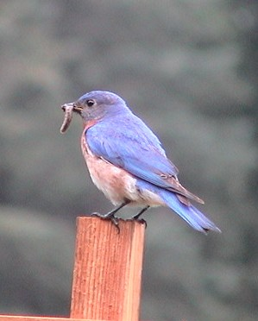
Consolidated Nest Box Summary - 2005
Brice Prairie Conservation Association - Individual Totals
Monitor's Name | Total Nest Boxes | Bluebirds Fledged | Bluebird Production Rate | Other Species Fledged |  |  |  | Total Other Species | Total Birds Fledged | Overall Production Rate
 |  |  |  | TS | CH | WR | Other | Total Other Species | Total Birds Fledged | Overall Production Rate
Iler Anderson | 91 | 439 | 4.82 | 74 |  |  |  | 74 | 513 | 5.64
Steve Anderson | 2 | 8 | 4.00 |  |  |  |  | 0 | 8 | 4.00
Bill Balmer | 37 | 151 | 4.08 | 51 |  | 6 |  | 57 | 208 | 5.62
Fred Craig | 210 | 1033 | 4.92 | 163 | 8 | 76 |  | 241 | 1274 | 6.07
Dave Fonger | 48 | 178 | 3.71 | 51 |  | 13 | 4 | 68 | 246 | 5.13
Brad Foss | 1 | 12 | 12.00 |  |  |  |  | 0 | 12 | 12.00
JoAnn Funk | 1 | 2 | 2.00 |  |  |  |  | 0 | 2 | 2.00
Dick Hellerude | 6 | 17 | 2.83 | 22 |  |  |  | 22 | 39 | 6.50
Joe Kawatski | 3 | 0 | 0.00 |  |  |  |  | 0 | 0 | 0.00
Skip Klein | 12 | 15 | 1.25 | 8 |  |  |  | 8 | 23 | 1.92
Rick Knuth | 5 | 15 | 3.00 | 9 |  |  |  | 0 | 15 | 3.00
Dick Marco | 61 | 308 | 5.05 | 89 |  |  |  | 89 | 397 | 6.51
Greg Marco | 3 | 2 | 0.67 | 3 |  |  |  | 3 | 5 | 1.67
Leif Marking | 274 | 1365 | 4.98 | 136 | 11 | 10 | 4 | 161 | 1526 | 5.57
Ron Page | 2 | 6 | 3.00 |  |  |  |  | 0 | 6 | 3.00
Dick Phillips | 14 | 71 | 5.07 | 17 |  |  |  | 17 | 88 | 6.29
Kent Stephan | 19 | 109 | 5.74 |  |  |  |  | 0 | 109 | 5.74
Leif Tolokken | 76 | 431 | 5.67 | 24 | 6 |  |  | 30 | 461 | 6.07
John Wiggert | 15 | 71 | 4.73 |  |  |  |  | 13 | 84 | 5.60
 | 880 | 4,233 | 4.81 | 647 | 25 | 105 | 8 | 783 | 5,016 | 5.70
Species Key: TS - Tree Swallow, CH - Chickadee, WR - Wren

Bluebird Production in Houses of Different Types

by Members of Brice Prairie Conservation Association
 | Number |  | Production | Predominant
Year | Houses | Fledged | Rate | House Type
1995 | 42 | 80 | 1.9 | Hill Lake
1996 | 54 | 109 | 2.0 | Tree Branch
1997 | 65 | 145 | 2.2 | Tree Branch
1998 | 78 | 212 | 2.7 | Tree Branch
1999 | 91 | 265 | 2.9 | Herman Olson
2000 | 101 | 324 | 3.2 | Herman Olson
2001 | 142 | 544 | 3.8 | NABS
2002 | 285 | 1,138 | 4.0 | NABS
2003 | 506 | 2,001 | 4.0 | NABS
2004 | 741 | 3,066 | 4.1 | NABS
2005 | 880 | 4,233 | 4.8 | NABS
 | Total | 12,117

